**Sanika Kadam**

**2124UCSF1112**

**ASSIGNMENT NO.7**

1. **Introduction**

Write a program to play video files. Design the UI with controls like play, pause, forward, and rewind. For instance, create a video player where users can watch tutorial videos stored on their device.

**2. Tools & Technologies Used**

* Android Studio
* Language-Java

**3. Procedure & Steps**

**Step 1: Create a New Project**

* Open Android Studio and create a new project.
* Select an second page activity by app-activity-page you selected
* Set the project name(Videoplayer)
* Select the programming language (Java).

**Screenshot:**

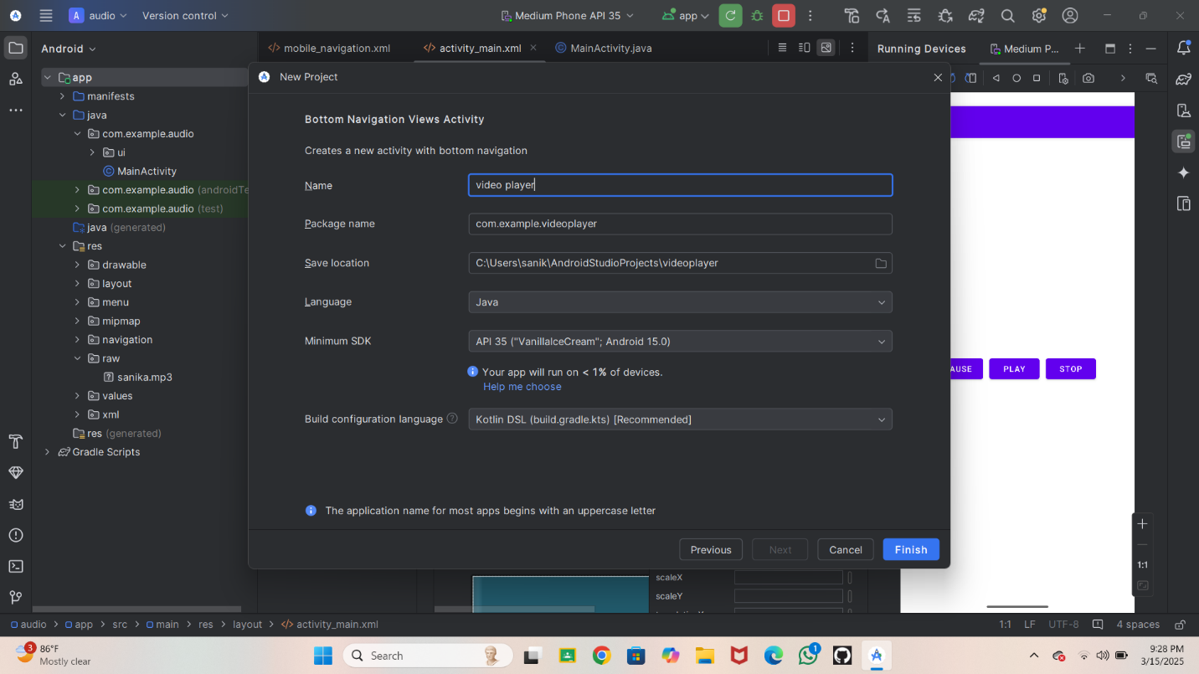

**Step 2: Designing the UI**

* Open activity_main.xml and design the layout using XML.
* Add UI components such as TextView, EditText, Button, etc.
* 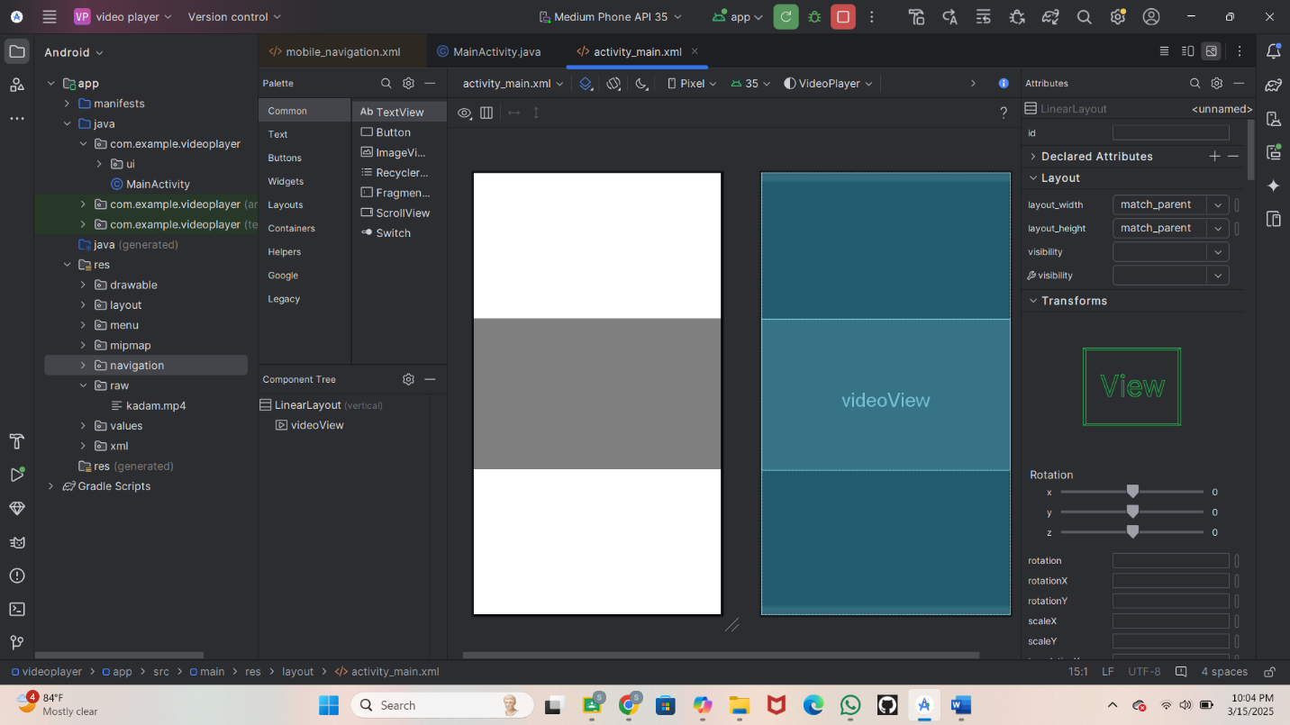

**Step 3: Writing the Code**

* Open MainActivity.java or MainActivity.kt.
* Implement functionality such as button clicks, form validation, etc.
* Use necessary Android components like Intents, RecyclerView, Fragments, etc.

activity_main.xml

<?xml version="1.0" encoding="utf-8"?>  
<LinearLayout  
 xmlns:android="http://schemas.android.com/apk/res/android"  
 android:layout_width="match_parent"  
 android:layout_height="match_parent"  
 android:orientation="vertical"  
 android:gravity="center"> <!-- Centering content inside the LinearLayout -->  
  
 <VideoView  
 android:id="@+id/videoView"  
 android:layout_width="match_parent"  
 android:layout_height="250dp" />  
  
</LinearLayout>

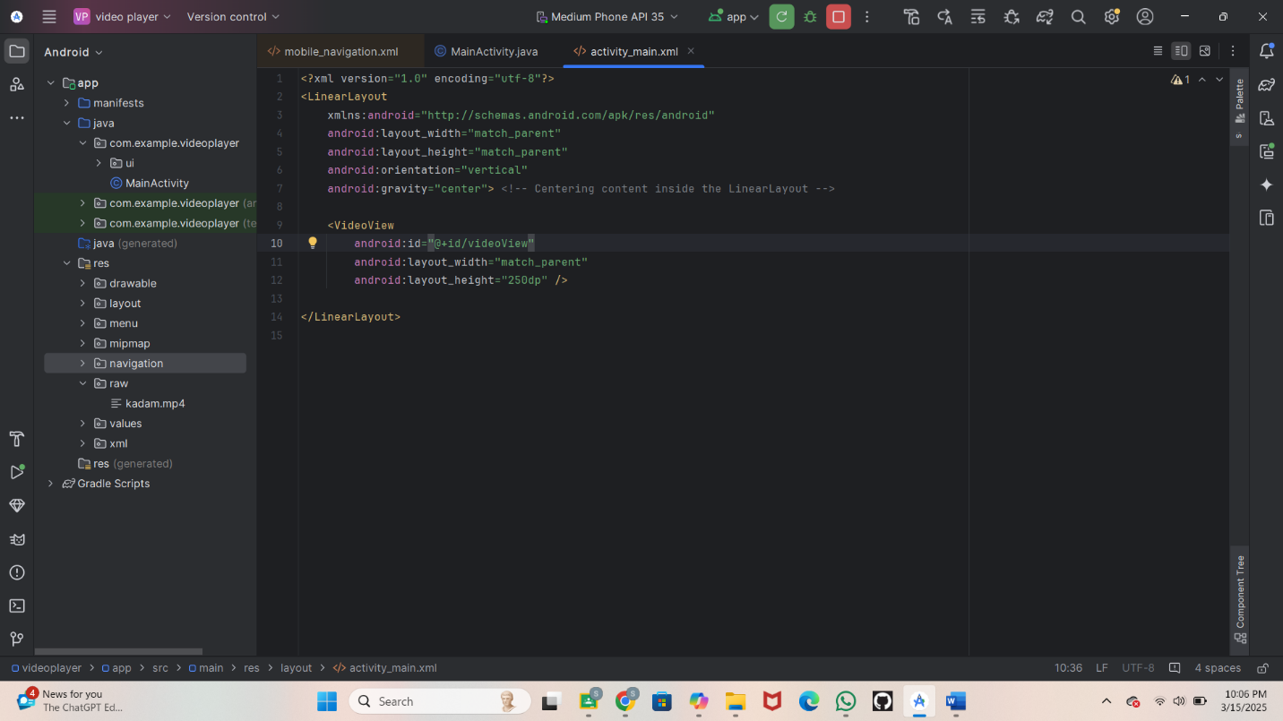

Step: Then write a code in main activity java

import android.net.Uri;  
import android.os.Bundle;  
import android.widget.MediaController;  
import android.widget.VideoView;  
  
import androidx.appcompat.app.AppCompatActivity;  
  
public class MainActivity extends AppCompatActivity {  
  
 @Override  
 protected void onCreate(Bundle savedInstanceState) {  
 super.onCreate(savedInstanceState);  
 setContentView(R.layout.*activity_main*);  
  
 // Get the VideoView by ID  
 VideoView videoView = findViewById(R.id.*videoView*);  
  
 // Define the correct path for the video resource in the res/raw folder  
 String vPath = "android.resource://" + getPackageName() + "/" + R.raw.*kadam*;  
  
 // Create URI from the path  
 Uri videoURI = Uri.*parse*(vPath);  
  
 // Set the URI for the VideoView  
 videoView.setVideoURI(videoURI);  
  
 // Create and set up the MediaController  
 MediaController mediaController = new MediaController(this);  
 videoView.setMediaController(mediaController);  
  
 // Attach the MediaController to the VideoView  
 mediaController.setAnchorView(videoView);  
  
 // Start playing the video  
 videoView.start();  
 }  
}

}

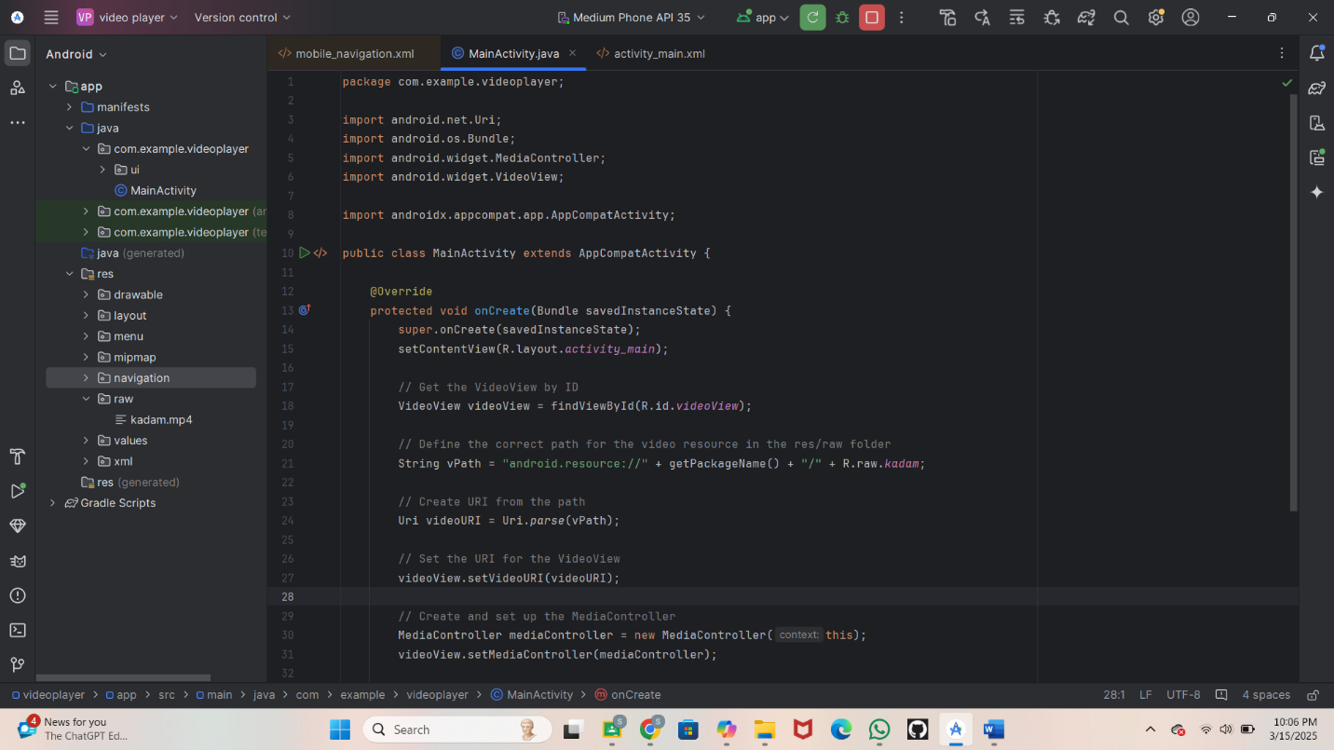

**Step 4: Running the Application on Emulator**

* Click on the **Run** button in Android Studio.

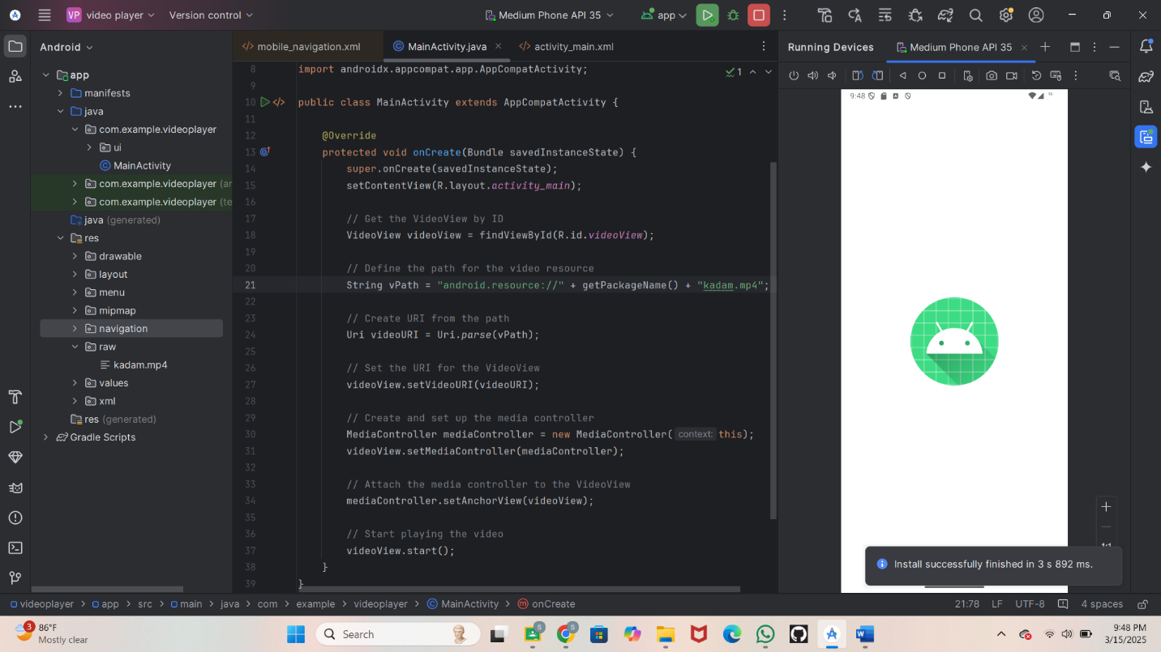

**Step : Start the video**

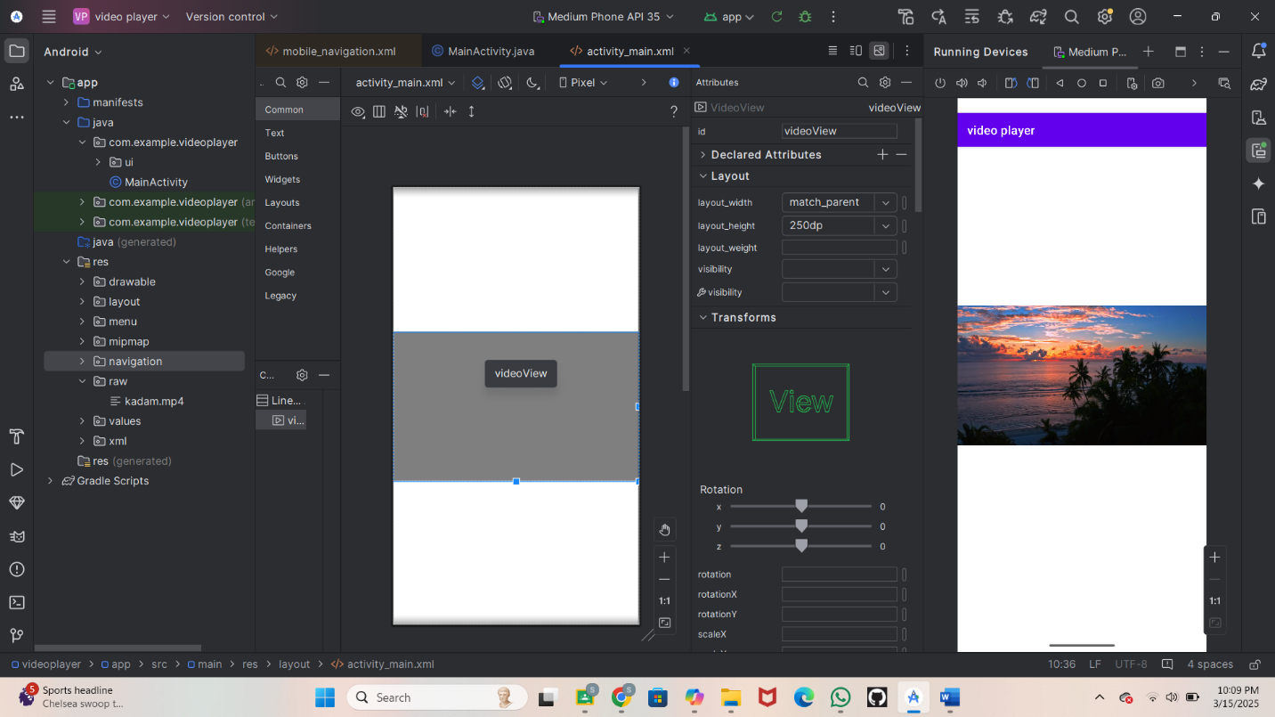

**Step 6: Testing & Output**

* **Test different functionalities of the app.**
* 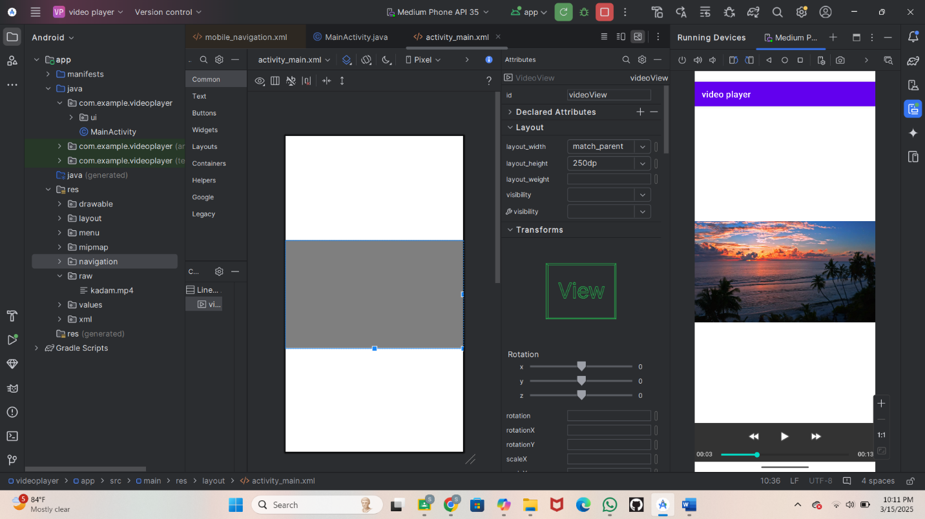

**Step 7 Conclusion**

This program creates a simple video player where users can play, pause, forward, and rewind videos. It's perfect for viewing tutorial videos stored on their devices with an easy-to-use interface.